

*Geophysical Research Letters*

Supporting Information for

**Paleogene marine and terrestrial development of the West Antarctic Rift System**

J. J. Coenen1*, R. Scherer1, P. Baudoin2, S. Warny2, I.S. Castañeda3, R. Askin2

1Department of Geology and Environmental Geosciences, Northern Illinois University, DeKalb, IL, USA.

2 Department of Geology and Geophysics and Museum of Natural Science, Louisiana State University, Baton Rouge, LA, USA.

3 Department of Geosciences, University of Massachusetts Amherst, Amherst, MA, USA.

**Contents of this file**

Text S1 to S7

Figures S5.1 to S6.1

Tables S1.1 to S3.1

**Introduction**

Details about the age constraints for the diatoms are discussed in Text S1, a table of total age ranges is presented Table S1.1 with their respective references Table S1.2, and distribution of diatoms from the Ross Embayment is presented in Table S3.1. A discussion about how we can use microfossils in tills is presented in Text S2. A more specific explanation of materials and methods used for this study are shown in Text S3. A more detailed discussion of biomarkers used for this study is presented in Text S4. Plates of characteristic diatoms, calcareous nannoplankton, and palynomorphs are presented in Text S5. A brief comparison between the original Eocene-Oligocene Boundary Paleotopography and the most recent model is presented in Text S6. A brief discussion on the utilization of palynomorphs is presented in Text S7.

Text S1. Paleogene biostratigraphic ranges

Glacial sediments recovered from beneath the WAIS, far from any subaerially exposed landmasses, are found to contain variable concentrations of Paleogene marine and terrestrial fossils. *Barron et al.* [2015]*,* compiled global biosiliceous Paleogene events, which provides a review of the biosiliceous productivity changes, which greatly helped this study. To constrain marine diatom ages we used a compilation of past studies including continental and ocean drilling studies highlighted in Supplemental Table 1.1 (biostratigraphic ages).

|  |  |  |  |
| --- | --- | --- | --- |
| Table S1.1 Biostratigraphically relevant diatom taxa | | | |
| Formal Name | FO (Ma) | LO (Ma) | Age References |
| *Actinocyclus octonarius* Ehrenberg, 1837 | 37.5 | 0 | 1 |
| *Asteromphalus symmetricus Schrader and Fenner,* 1972 | 28 | 20 | 2 |
| *Aulacodiscus* cf. *brownei Boyer, 1927* | 28 | 11 | 3, [*Harwood et al.,* 1989] |
| *Hemiaulus polycystinorum Ehrenberg, 1840* | 41 | 16 | 4,5 |
| *Hemiaulus polymorphus Grunow &* Homann, 1991 | 63 | 7 | 1 |
| *Pseudotriceratium radiosoreticulatum (Grunow*) Fenner | 35 | 28 | 5 |
| *Pterotheca aculifera Grunow, 1880* | 61 | 24 | 4 |
| *Pyxilla reticulata* Grove and Sturt, 1887 | 46.6 | Post-Eocene | 6 |
| *Skeletonemia? utriculosa Sims 1994* | 34.5 | 31.5 | 7 |
| *Stephanopyxis grunowii* Grove and Sturt; Harwood, 1989 | 56 | 21 | 1,2,4,5 |
| *Triceratium crenulatum Grove and* Sturt, 1887 | 57 | 33.9 | 8 |
| *Trinacria simulacrum* Grove & Sturt, 1887 | Paleocene | 44.9 | 6 |

|  |  |
| --- | --- |
| Table S1.2 Diatom biostratigraphic age range references. | |
| Reference number | Reference |
| 1 | Hajos, M. (1975) *Initial Rep. Deep Sea Drill. Proj.* **29,** 913-1009. |
| 2 | Gombos, A. M., Jr. & Ciesielski, P. F. (1983) *Initial Rep. Deep Sea Drill. Proj.* **71,** 583-634 |
| 3 | McCollum, D.W., (1975) *Initial Rep. Deep Sea Drill. Proj.* **28,** 515-571. |
| 4 | Fenner, J. (1978) *Initial Rep. Deep Sea Drill. Proj.* **38–41,** 491–624. |
| 5 | Dzinoridze, R., (1978) Initial Rep. Deep Sea Drill. Proj. **38-41,** 289-427. |
| 6 | Barron (2015) *Palaeogeography, Palaeoclimatology, Palaeoecology422,* 85-100. |
| 7 | Harwood & Bohaty (2001) *Terra Antarctica* **8**(4), 315-338. |
| 8 | Hajos, M. (1976) *Initial Rep. Deep Sea Drill. Proj.* **35,** 817-883. |

**Table S1.3** Table of diatom and other siliceous microfossils occurrences. This study and previously studied sites presented for comparison. X indicates the taxa was observed at the site.

|  |  |  |  |  |  |  |  |
| --- | --- | --- | --- | --- | --- | --- | --- |
|  | **This study** | | | | **Other studies** | | |
| **Diatoms** | **SLW** | **KIS** | **BIS** | **WGZ** | **RISP** | **UpB** | **CIR** |
| *Actinocyclus fryxellae* Baldauf and Barron | X | X |  |  | X | X | X |
| *Actinocyclus ingens* Rattray |  | X |  | X |  |  | X |
| *Actinocyclus octonarius*, Hustedt | X | X |  | X | X | X | X |
| *Actinocyclus* sp. A, Baldauf and Barron | X | X |  | X |  | X | X |
| *Actinocyclus* spp. | X | X |  | X | X | X | X |
| *Actioncyclus actionchilus*, Simonsen |  |  |  | X |  | X |  |
| *Acinocyclus* sp. cf. *A.* *actinochilus* " early form" |  |  |  |  |  | X |  |
| *Actinoptychus senarius*, Ehrenberg |  |  | X | X | X | X | X |
| *Asteromphalus hookerii* Ehrenberg |  |  |  |  |  | X |  |
| *Asteromphalus parvulus* Karsten |  |  |  |  |  | X |  |
| *Asteromphalus* *symmetricus* Schrader and Fenner, |  |  |  | X | X |  |  |
| *Aulacodiscus brownei* Boyer |  |  |  | X | X |  |  |
| *Biddulphia* spp. |  |  | X | X | X | X | X |
| *Cocconeis* spp. |  |  |  | X |  |  |  |
| *Coscinodiscus* spp. | X | X |  | X | X | X | X |
| *Coscinodiscus asteromphalus* Ehrenberg |  |  |  |  |  |  |  |
| *Denticulopsis* *macollumii* (McCollum) Simonsen |  |  |  |  | X |  | X |
| *Denticulopsis* *delicata* Yangisawa and Akiba | X | X |  |  |  | X | X |
| *Denticulopsis* *simonsenii* (Simonsen and Kanaya) Siomsen | X | X |  | X | X | X | X |
| *Denticulopsis* *lauta* (Bailey) Simonsen |  |  |  |  | X |  |  |
| *Denticulopsis* *maccollumi* McCollum (Geronde and Burckle) |  |  |  |  | X |  |  |
| *Dicladia* spp. Ehrenberg (Harwood and Bohaty) |  |  | X |  |  |  |  |
| *Eucampia* *antarctica* Castracane, 1886 | X | X |  | X | X | X | X |
| *Fragilariopsis* *aurica* (Geronde) |  |  |  |  |  |  | X |

(continued on the following page)

(Table S1.3 continued)

|  |  |  |  |  |  |  |  |
| --- | --- | --- | --- | --- | --- | --- | --- |
|  | **This study** | | | | **Other studies** | | |
| **Diatoms** | **SLW** | **KIS** | **BIS** | **WGZ** | **RISP** | **UpB** | **CIR** |
| *Fragilariopsis cylindrus* (Grunow) |  |  |  | X |  |  |  |
| *Fragilariopsis* *donahuensis* (Schrader) |  |  |  |  |  | X |  |
| *Fragilariopsis* *obliquicosta* (O’Meara) Hasle |  | X |  | X |  |  |  |
| *Fragilariopsis* *grossepunctata* Schrader |  |  |  |  |  |  | X |
| *Fragilariopsis* *obliquicostata* (Van Heurck) Hasle |  | X |  |  | X |  |  |
| *Fragilariopsis* *praecurta* Gersonde | X |  |  |  |  |  | X |
| *Fragilariopsis* *ritscheri* (Hustedt) Hasle |  | X |  |  |  |  |  |
| *Fragilariopsis* *sublinearis* (Van Heurck) Hasle |  | X |  |  |  |  |  |
| *Fragilariopsis* spp. | X | X |  | X | X | X |  |
| *Grammatophora* spp. Ehrenberg |  |  |  | X |  |  |  |
| *Hemiaulus polycistornum* Ehrenberg |  |  | X | X |  |  |  |
| *Hemiaulus* *polymorphus* Grunow, Homann |  | X | X | X |  |  |  |
| *Hemiaulus polymorphus* var. *morsiana* Grunow |  |  | X |  |  |  |  |
| *Hemiaulus* spp. |  |  | X | X |  |  |  |
| *Hemiaulus subactus* Grunow |  |  | X |  |  |  |  |
| *Nitzschia* sp. 17 Schrader |  |  |  |  | X |  | X |
| *Paralia* *sulcata* (Ehrenberg) Cleve (Hustedt) | X | X | X | X | X | X | X |
| *Paralia* *sulcata* “oval form” (Ehrenberg) Palermer |  |  | X |  |  |  |  |
| *Porosira* *pseudodenticulata* (Hustedt) Jouse (Kozlova) | X |  |  | X |  | X |  |
| *Proboscia spp.* | X | X |  | X |  |  |  |
| *Psedotriceratium* *radiosoreticulatum* (Grunow) Fenner | X |  |  | X |  |  |  |
| *Pseudopodosira westii* W. Smith |  |  | X | X |  |  |  |
| *Pterotheca* *aculeifera* Grunow, Forti |  |  | X | X |  |  |  |
| *Pyxilla reticulata* Grove and Sturt | X | X | X | X |  |  |  |
| *Raphidodiscus* *marylandicus* Christian |  |  |  |  | X |  |  |

(continued on the following page)

(Table S1.3 continued)

|  |  |  |  |  |  |  |  |
| --- | --- | --- | --- | --- | --- | --- | --- |
|  | **This study** | | | | **Other studies** | | |
| **Diatoms** | **SLW** | **KIS** | **BIS** | **WGZ** | **RISP** | **UpB** | **CIR** |
| *Rhizosolenia* spp. | X | X |  | X |  |  |  |
| *Rouxia* *californica* (Peragallo) |  |  |  |  |  |  | X |
| *Skeletonema utriculosa* Brun; Sims |  |  | X | X |  |  |  |
| *Stellarima* *microtrias* (Ehrenberg) Hasle and Sims | X | X | X | X | X | X | X |
| *Stellarima* *stellaris* (Roper) Hasle and Sims |  | X |  |  | X | X | X |
| *Stephanodiscus?* *(Mesodictyon?)* sp. A Scherer | X |  |  |  |  | X |  |
| *Stephanopyxis* *grunowii* Grove and Strut; Harwood |  |  | X | X |  |  |  |
| *Stephanopyxis* sp. F (Harwood and Bohaty) |  |  | X |  |  |  |  |
| *Stephanopyxis* spp. | X | X | X | X | X | X | X |
| *Stephanopyxis* *turris* (Greville and Arnott) Ralfs group (Pritchard) | X |  | X | X | X |  | X |
| *Synedropsis* *creanii* Olney |  | X |  |  |  |  |  |
| *Thalassionema* spp. | X | X |  | X |  |  |  |
| *Thalassiosira* *antarctica* Comber | X | X |  | X |  | X |  |
| *Thalassiosira* *fraga* Schrader (Schrader and Fenner) |  |  |  |  | X |  |  |
| *Thalassiosira* *gersondei* Baldauf and Barron |  |  |  |  |  | X |  |
| *Thalassiosira* *gracilis* var. *expecta* (Van Landingham) Fryxell and Hasle |  |  |  |  |  | X |  |
| *Thalassiosira* *lentiginosa* (Janisch) Fryxell |  |  |  | X |  | X |  |
| *Thalassiosira* *mahoodii* (Barron) |  |  |  |  |  | X |  |
| *Thalassionema* *nizschiodes* (Grunow) Peragallo | X |  |  |  |  | X | X |
| *Thalassiosira* *oliverana* (O'Meara) Makarova and Nikolaev |  | X |  |  | X |  | X |
| *Thalassiosira* *oliverana* var. *sparsa* Harwood and Maruyama | X | X |  | X | X | X | X |
| *Thalassiosira* *ritscheri* (Hustedt) Hasle |  |  |  |  |  | X |  |

(continued on the next page)

163

(Table S1.3 continued)

|  |  |  |  |  |  |  |  |
| --- | --- | --- | --- | --- | --- | --- | --- |
|  | **This study** | | | | **Other studies** | | |
| **Diatoms** | **SLW** | **KIS** | **BIS** | **WGZ** | **RISP** | **UpB** | **CIR** |
| *Thalassiosira* *striata* var. "offcenter" sensu Harwood and Maruyama, |  |  |  |  |  | X |  |
| *Thalassiosira* *torokina* Brady | X | X |  | X |  | X | X |
| *Thalassiosira* *trifulta* Fryxell (Fryxell and Hasle) | X | X |  |  |  | X | X |
| *Thalassiothrix* spp. | X | X |  | X |  |  |  |
| *Triceratium* *crenulatum* Grove and Strut, (Stearn) |  |  | X |  |  |  |  |
| *Triceratium* *favus* var. *quadrata* Grunow |  |  | X |  |  |  |  |
| *Trinacria* *excavata* Heiberg | X | X |  | X | X | X |  |
| *Trinacria* *simulacram* Grove and Strut |  |  | X |  |  |  |  |
| *Xanthiopyxis* spp. Ehrenberg |  |  | X | X |  |  |  |
| **Ebridians** | **SLW** | **KIS** | **BIS** | **WGZ** | **RISP** | **UpB** | **CIR** |
| *Ammonodochium* sp. | X |  |  | X |  |  |  |
| *Ammonodochium* *rectagulare* | X |  |  | X |  |  |  |
| *Pseudammodochium* sp. Cf. *P.* *dictyoides* of Ling | X |  |  | X |  |  |  |
| *Pseudammodochium lingii* Bohaty and Harwood |  |  |  | X |  |  |  |
| *Parathranium* sp. |  | X |  |  |  |  |  |
| **Silicoflagellates** | **SLW** | **KIS** | **BIS** | **WGZ** | **RISP** | **UpB** | **CIR** |
| *Dictyocha* *defladrei* Frenguelli (Glezer) | X |  |  | X |  |  |  |
| *Distephanus* *speculum* *speculum* (Ehrenberg) Haeckel |  | X |  | X |  |  |  |
| Silicoflagellate fragments | X | X |  | X | X | X | X |

Text S2. Till and Transport

Micropaleontologic analysis of till has special challenges. Deformation tills may have undergone high shear strains, leading to fragmentation of fossils in ways that differ than that resulting from normal load compaction (Scherer et al., 2004, 2005)*.* Moreover, glacial erosion and transport often leads to mixtures of assemblages of microfossils derived from strata of different ages [*Sjunneskog & Scherer*, 2005]*.* This stratigraphic mixing eliminates the ability to utilize the biostratigraphic application of co-occurring taxa generally utilized in the identification of partial range zones. Thus, only total range zones (first to last stratigraphic occurrence) of well-established taxa can be used to unequivically identify distinct ages, yielding significantly lower biostratigraphic resolution. When distinct sediment clasts are present in a till matrix it is possible to evaluate particular stratigraphic units and aid in identifying different source beds mixed into the till matrix[*Harwood et al.,* 1989]*.*

To date, the only subglacial sediments recovered from the WAIS by coring are the uppermost tills (<3m). No core to date has penetrated the till layer to access in situ strata beneath. Furthermore, no subglacial sediment samples have been recovered from topographic highs beneath the central West Antarctic Ice Sheet. High concentrations of a tracer (e.g., fossils) in the till that represent a single age is inferred to reflect active or recent and proximal erosion by glacial flow of strata beneath the deforming till layer. Good preservation of delicate diatoms implies less cumulative shear strain, suggesting relatively short transport distances [*Scherer et al.,* 2005].

In this study, Site 2 (KIS) and Site 3 (UpB) contain pollen clusters (microclasts) suggesting Eocene pollen is likely close to the initial source. Site 3 (UpB) microclasts of lake diatoms of presumed Eocene age, which are also found at Site 4 (SLW) in trace concentrations, suggest that there were likely deposits located proximally upstream from present day Site 3 (UpB), whereas the rare occurrence of individual fossils in Site 4 (SLW) indicate subglacial transport from upstream. Site 1 (BIS) has the least stratigraphic mixing, with no evidence of post-Paleogene fossils, which implies complete removal of younger strata and active erosion of Paleogene sediments.

Text S3. Materials and Methods

Text S3.1 Materials and previous work

Glacial sediments recovered from different subglacial and sub-ice shelf deposits were analyzed to establish stratigraphic and environmental origins of their components. For More information on Sites 1-3 we direct you to *Kamb,* [2001] for discussions of glaciological studies on these materials. Sampling locations include (Table S3.1):

* Shallow sediment cores from Subglacial Lake Whillans (SLW; Site 4), at the onset of the Ross Ice Shelf in a narrow and shallow (10m) marine embayment near the Whillans Ice Stream Grounding Zone (WGZ; Site 5), recovered as part of the WISSARD (Whillans Ice Stream Subglacial Access Research Drilling) project on the downstream portion of the rapidly flowing Whillans Ice Stream.
* An array of sediment cores and other samples recovered from the upstream portion of the Whillans Ice Stream (UpB; Site 3) [*Kamb*, 2001]in 1989, 1990, 1991, and 1995.
* Sediment cores collected from beneath the upstream portion of the Kamb Ice Stream (UpC; Site 2) [*Kamb*, 2001] in 1996, and the downstream sticky spot component of UpC sampled in 2000.
* A single sediment core collected from beneath the Bindschadler Ice Stream (UpD; Site 1) [*Kamb,* 2001], north of Kamb Ice Stream in 1998.
* Microfossil data from past studies of Crary Ice Rise (CIR; Site 7) [*Scherer et al.,* 1988]and Ross Ice Shelf Project (RISP; Site 6) [*Harwood et al., 1989*]*.*

Table S3.1: Site location information

|  |  |  |  |
| --- | --- | --- | --- |
| Locations | Latitude | Longitude | Sites and Field Year |
| Site 1 - BIS | -81.06 | -140.01 | Bindschadler Ice Stream*,* 1998 |
| Site 2A.1 -KIS | -82.49 | -135.96 | Kamb Ice Stream, 1996: KIS-96-10-CW: Core water from coring site 10 |
| Site 2A.2 - KIS | -82.44 | -135.96 | Kamb Ice Stream, 1996: KIS-96-13: from coring site 13 |
| Site 2A.3 - KIS | -82.39 | -135.47 | Kamb Ice Stream, 1996: KIS-96-6: from coring site 6 |
| Site 2B.1 - KIS | -82.36 | -136.40 | Kamb Ice Stream, 2000: KIS-00-3: from coring site 3 the “sticky spot” |
| Site 2B.2 - KIS | -82.43 | -136.40 | Kamb Ice Stream, 2000: KIS-004: from coring site 4 |
| Site 3 - WIS | -83.45 | -137.76 | Whillans Ice Stream, UpB camp*,* 1990, 1992 |
| Site 4 - SLW | -84.24 | -153.73 | Subglacial Lake Whillans ([www.WISSARD.org](http://www.WISSARD.org)), 2013 |
| Site 5 - WGZ | -84.33 | -163.61 | Whillans Grounding Zone ([www.WISSARD.org](http://www.WISSARD.org)), 2015 |
| Site 6 - RISP | -82.36 | -172.49 | Ross Ice Shelf Project*,* 1978, 1979 |
| Site 7 - CIR | -82.90 | -172.49 | Crary Ice Rise*,* 1987 |

These tills from a suite of sediments recovered from beneath the southern Ross Ice Shelf and grounded WAIS were analyzed for siliceous microfossils, dominantly diatoms but also sponge spicules, chrysophyte cysts, silicoflagellates, ebridians, and radiolarians. Rare calcareous fossils encountered include mollusc fragments, calcareous nannofossil, foraminifera, and echinoderm fragments. Organic walled microfossils include marine and non-marine palynomorphs such as, pollen, spores, dinoflagellate cysts, and fungal spores. All of these fossils are recycled and mixed in glacial tills [*Sjunneskog & Scherer, 2005*]*.*

Text S3.2. Diatom methods

Diatom relative abundance data was collected on material that was sieved at 10 and 25 microns. Sieving and isolating identifiable fragments was the primary means for characterizing these sediments (See Text S2. Till and transport section). Additionally, samples were processed using the *Warnock & Scherer* [2015]*,* settling method for quantitative counts of fragment abundance. Photographic documentation using a Leica MC170HD camera was done at Northern Illinois University to identify marine diatoms at 1,000X magnification using oil immersion on a Leica DMLB microscope. When possible 200-300 marine diatoms were identified for relative counts. Only age specific taxa were used to constrain these Paleogene Marine events reported here, following a compilation of published Paleogene and Neogene diatom biostratigraphic data from the Southern Ocean and the Paleogene deposits from the Antarctic (Supplemental Table S1.1).

Text S3.3. Palynology methods

All samples were processed by the Canadian palynological processing company Global Geolab Limited. Dried samples were weighed and spiked with a known quan­tity of *Lycopodium* spores to calculate palynomorph concentration. Digestion of the sediment was achieved through successive treatment of hydrochloric acid followed by hydrofluoric acid to dissolve carbonates and siliciclastics respectively. Heavy liquid separation utilizing sodium poly­tungstate and/or filtration using a 10 μm sieve was then performed to remove fine debris. Resi­dues were mounted on palynological slides. Palynomorphs were counted on an Olympus BX41 microscope at CENEX, under 60x and 100x immersion objectives. All species recovered were carefully described, tabulated, and photographed using a QCapture camera and software. Where possible, 300 grains were counted per slide, and when the palynomorph yield was low, a second slide was analyzed. Palynomorphs were identified to the lowest taxonomic level possible. Concen­tration was calculated using the *Benninghoff* [1962] equation: C= (Pc×Lt×T)/(Lc×W), where C = concentration (per gram of dried sediment, gdw-1), Pc = the number of palynomorphs counted, Lt = the number of *Lycopodium* spores per tablet, T = the total number of *Lycopodium* tablets added per sample, Lc = the number of *Lycopodium* spores counted, W = the weight of dried sediment.

Text S3.4. Biomarker methods

Organic geochemical analyses were performed at the Biogeochemistry Laboratory at the University of Massachusetts Amherst. Freeze-dried sediment samples were extracted with an Accelerated Solvent Extractor 200 (Dionex) using dichloromethane (DCM):methanol 9:1 (v:v). The resulting total lipid extract (TLE) was dried under N2 and subsequently separated into neutral lipid and fatty acid fractions using aminopropylsilyl columns and eluted with DCM:isopropanol (2:1) and ethyl ether:acetic acid (24:1). This study focuses on the neutral lipid fractions, which were separated into apolar, ketone, and polar fractions by sequential elution over activated alumina oxide (Al2O3) using DCM:hexane (9:1, v:v) (apolar), DCM:hexane (1:1, v:v) (ketone), and DCM:methanol (1:1, v:v) (polar) as the eluents.

Each polar fraction was split in half. One split was filtered through a 0.45 μm PTFE filter in hexane:isopropanol (99:1, v:v) and a known quantify of a C46 glycerol dialkyl glycerol tetraether (GDGT) internal standard was added. Isoprenoid and branched GDGTs (iGDGTs and brGDGTs) were quantified with respect to the C46 standard, assuming equal ionization efficiency for all compounds. The GDGTs were analyzed with an Agilent 1260 Ultra High Performance Liquid Chromatograph (UHPLC) coupled to an Agilent 6120 Mass Selective Detector in selected ion monitoring (SIM) mode for the major brGDGT protonated molecules [*M* + *H*]+) following the method of *Hopmans et al.* [2016]*,* which separates the 5-methyl and 6-methyl brGDGT isomers. This method utilizes two Waters BEH HILIC silica columns (2.1 x 150 mm, 1.7 μm) in series with a Waters 2.1 x 5mm pre-column of the same material [*Hopmans et al.,* 2016]*.* GDGTs were isocratically eluted for the first 25 minutes using a mixture of 100% hexane (solvent A) and hexane:isopropanol (9:1, v/v, solvent B) at a ratio of 18% solvent B, then a linear increase to 35% solvent B in 25 minutes, and finally a linear gradient to 100% solvent B in 30 minutes [*Hopmans et al.,* 2016]. The flow rate was 0.2 ml/minute and temperature was held constant at 30°C.

The other half of each polar fraction was derivatized using a mixture of equal parts bistrimethylsiyltrifluoroacetamide (BSTFA) and acetonitrile and heated in an oven at 70°C for 30 minutes. Samples were subsequently dried under N2 and re-dissolved in ethyl acetate. The apolar and ketone fractions were gently dried under N2 and dissolved in hexane prior to analysis. Compounds in the apolar and ketone fractions were identified with a Hewlett-Packard 6890 Series gas chromatograph coupled to an Agilent 5973 mass spectrometer (GC-MS) using a Restek Rtx-5ms (60m x 250µm x 0.25 µm) column. Compounds were quantified with an Agilent 7890A dual gas chromatograph-flame ionization detector (GC-FID) equipped with two Agilent 7693 autosamplers and two identical columns (Agilent 19091J-416: 325°C: 60m x 320µm x 0.25 µm, HP-5 5% Phenyl Methyl Siloxane). For both the GC-MS and GC-FID, hydrogen was used as the carrier gas. The oven programs for the apolar and derivatized polar fractions began at a temperature of 70 oC, increased at 17 oC min -1 to 130 oC, increased again at 4 oC min -1 to 320 oC, and then held for 15 minutes. The oven program for the ketone fraction initiated at 70 oC, increased at 30 oC min -1 to 130 oC, increased again at 4 oC min -1 to 320 oC, and then held for 15 minutes. Compounds were quantified using an external calibration curve where squalane was injected at multiple concentrations ranging from 2 to 100 ng/μl and r2 values for linearity tests were >0.99.

Text S3.4.1 GDGT temperature reconstructions

Text S3.4.1.1 TEX86

The Tetraether Index of 86 carbon atoms (TEX86) provides a temperature proxy in marine and lacustrine environments and is based on the degree of cyclization of isoprenoid GDGTs produced by aquatic Thaumarchaeota [*Schouten et al.,* 2002]*.* The TEX86 ratio was calculated following *Schouten et al*. [2002]*:*

TEX86 [1]

where the different GDGTs refer to the structures presented in *Schouten et al.* [2002]*.* To convert TEX86 values to sea surface temperature (SST), we apply the equation reported by *Kim et al.* [2008]:

T = -10.78 + 56.2*TEX86 (calibration error ±1.7°C) [2]

We chose to apply the *Kim et al.* [2008],calibration because the mixed sources and ages of the material analyzed here precludes applying the BAYSPAR calibration [*Tierney & Tingley*, 2014]*,* which requires knowledge of paleolatitude and paleolongitude of the sample site. Although the mixed nature of the till samples studied here means that TEX86 and MBT’5ME reconstructed temperatures (see below) should not be interpreted at face value, these analyses can provide insights to the depositional setting of each sample (e.g. significantly higher temperatures than today in conjunction with our microfossil data support an Eocene origin for the BIS samples).

Text S3.4.1.2 MBT’5Me

The methylation index of branched tetraethers (MBT) is based on brGDGTs and was first developed as a proxy for mean annual soil (air) temperature [*Weijers et al.,* 2007]*.* The source organism of brGDGTs remains unknown evidence but evidence points to *Acidobacteria* as a likely producer [*Weijers et al.,* 2006, 2007; *De Jonge et al.,* 2014]*.* Here, we calculated the MBT’5ME index, which uses only the 5-methyl brGDGT isomers to reconstruct mean annual soil (air) temperatures, following *De Jonge et al.* [2014], where the different GDGTs refer to the structures presented *Weijers et al.* [2007] and *De Jonge et al.* [2014]:

MBT’5ME = (Ia + Ib + Ic) / (Ia + Ib + Ic + IIa + IIb + IIc + IIIa + IIIb + IIIc) [3]

MBT’5ME values were then converted to temperature using the calibration equation of *De Jonge et al.* [2014]*,* which is based on a suite of globally distributed soil samples:

MAAT = -8.57 + 31.45 × MBT’5ME (RMSE=4.8°C) [4]

Text S3.4.2 BIT Index

The Branched and Isoprenoid Tetraether (BIT) index, which in marine environments provides a proxy for soil versus marine organic matter input to sediments, was calculated following *Hopmans et al.* [2004]:

$BIT=\frac{(GDGTI+GDGT II+GDGT III)}{(GDGT I+GDGT II+GDGT III+crenarchaeol)}$ [5]

A BIT Index values of 0.9 to 1 represent a soil organic matter source while a value of 1 represents an entirely marine source [*Hopmans et al.,* 2004]*.*

Text S3.4.3 Plant leaf wax sources and ratios

Plant leaf waxes, including the long-chain (C27-C35) *n*-alkanes, are a characteristic biomarker of terrestrial higher plants [*Eglinton & Hamilton,* 1967] while aquatic algae produce shorter-chain homologues (C17-C21 *n*-alkanes)*.* Therefore, the ratio of the long- (C27 + C29 + C31) to short-chain (C15 + C17 + C19) *n*-alkanes can be used to assess terrestrial vs. aquatic organic matter sources [*Meyers,* 1997]. In the samples analyzed here the shortest chain-length present was generally C21. Thus, we use a modified T/A ratio of [(C29+C31)/(C21+C23)]. We note that the same overall pattern exists if only *n*C21 is used as the aquatic endmember. The *n*-alkane average chain length (ACL) has been observed to increase with increasing aridity or temperature at some, but not all, locations [e.g. *Bush & McInerney,* 2013].

Text S4. Biomarker supplemental discussion

Organic matter provides a direct indicator of life at the time of sediment deposition. Although glacial tills may contain mixtures of material deriving from different sources, prior research has established that biomarkers can provide a chemostratigraphic tool to aid in differentiating different till deposits. For example, *Battram et al.* [2015] examined tills from the Hudson Bay Lowlands and identified compositional differences between the Severn, Sachigo and rocks and tills. Our biomarker results here offer a similar finding as tills originating from the six study locations are characterized by differing compound distributions.

Text S4.1 Plant Leaf Waxes

Plant leaf waxes, including the long-chain (C27-C35) *n*-alkanes, are a characteristic biomarker of terrestrial higher plants [*Eglinton and Hamilton,* 1967] while aquatic algae produce shorter-chain homologues (C17-C21 *n*-alkanes)*.* The six locations studied here, Bindschadler Ice Stream (BIS; Site 1), Kamb Ice Stream (KIS; Site 2), Whillans Ice Stream (UpB; Site 3), Subglacial Lake Whillans (SLW; Site 4), Whillans Grounding Zone (WGZ; Site 5), and Ross Ice Shelf Project (RISP; Site 6), all exhibit somewhat differing *n*-alkane concentrations and ratios (Fig. 3a-c). The ratio of long- to short-chain *n*-alkanes provides a relative assessment of terrestrial vs. aquatic inputs [*Meyers,* 1997]; here samples from sites WGZ and RISP are characterized be low T/A values suggesting mainly aquatic inputs whereas site BIS has the highest T/A values suggesting terrestrial inputs. The pattern seen in the T/A *n*-alkane ratio between sites is independently confirmed by the Branched and Isoprenoid (BIT) Index [*Hopmans et al.*, 2004]values (Fig. 3a,f). Sites KIS and BIS are marked by the highest concentration of long-chain *n*-alkanes (Fig. 3b,g). The *n*-alkane average chain length (ACL; Fig. 3d) is the highest at BIS. This is interesting because ACL has been observed to increase with increasing aridity or temperature at some, but not all, locations [*Bush & McInerney,* 2013] While much caution should be applied when inferring past temperature or aridity conditions from ACL values alone, here it is notable that the pattern observed in the ACL values between sites genreally tracks that of reconstructed TEX86 and MBT’5ME values (Figure 3d,e,g). Another interesting feature of the n-alkane data is that two samples from KIS (Site 2A.2-KIS-UpC 96-10-1 and Site 2A.1, KIS-UpC 96-6-1-CW) have significantly higher concentrations of mid-chain *n*-alkanes than the other sites (Fig. 3c). These samples are equivalent to sample KIS-UpC-96-10-CW (Site 2A.2), which contained a rich assemblage of sphagnum spores and included visible lignite fragments, and thus the leaf wax data support enviornnmental inferences drawn from the palynomorph data (see main text).

Text S4.2 GDGTs

Glycerol dialkyl glycerol tetraethers (GDGTs) are compounds that are widespread in marine and terrestrial environments. The isoprenoid GDGTs are produced by marine Thaumarchaeota and form the basis of the TEX86 sea surface temperature (SST) proxy [*Schouten et al.,* 2002, 2013]*.* Likewise, the MBT’5Me proxy, based on branched GDGTs, is used for continental paleotemperature reconstruction [e.g. *Weijers et al.,* 2007; *De Jonge et al.,* 2014]. Branched GDGTs are produced by an unknown source organism but evidence points to *Acidobacteria* as a likely producer [*Weijers et al.,* 2007]. brGDGTs are common in soils, peats, and freshwater (lakes and rivers) [*Weijers et al.,* 2007]*.* When found in marine environments, typically brGDGTs reflect soil organic matter input*.* Similarly, the Branched and Isoprenoid Tetraether (BIT) Index is a ratio of the branched GDGTs to crenarchaeol (a compound produced by marine Thaumarchaeota) and is used to examine relative inputs of marine (BIT Index value =0) to soil (BIT Index value = 0.9 to 1.0) organic matter inputs [*Hopmans et al.,* 2004]*.*

The mixed nature of the till samples studied here means that TEX86 and MBT’5ME reconstructed temperatures should not be interpreted at face value; however, these data offer evidence for these tills reflecting Paleogene environments while also highlighting differences between the various study sites. Today mean annual air temperature on Antarctica ranges from approximately 0˚C near the coast to -50˚C in the continental interior *Nicolas & Bromwich* [2014]*.* Likewise, sea surface temperatures immediately surrounding the Antarctic continent are 1 to -2˚C. While multiple temperature calibrations exist for TEX86, which will impact the resulting absolute reconstructed temperatures, it is notable that both TEX86 and MBT’5ME yield similar patterns of relative temperature variability at all sites (Fig. 3e,g). At all sites reconstructed TEX86 and MBT’5ME temperatures are well above modern temperatures, pointing to the inclusion of older material from past warm climates in the glacial tills we analyzed. Notably, at Site 1 (BIS), where microfossils from post Paleogene strata are lacking, the highest TEX86 and MBT’5ME temperatures are observed, consistent with a dominantly Eocene greenhouse origin as suggested by the diatom assemblages (see main text). Site 1 (BIS) samples are also characterized by the highest BIT Index values of any site (Fig. 3f), indicating an origin from soil organic matter. In contrast, Site 6 (RISP) and Site 5 (WGZ) are characterized by lower BIT Index values indicating dominant inputs from marine-derived organic matter [*Hopmans et al.,* 2004] whereas other sites indicate a wider spread of BIT Index values, suggesting a mixture of marine and soil-derived organic matter.

Text S5. Characteristic marine diatoms, calcareous nannoplankton, and palynomorph plates

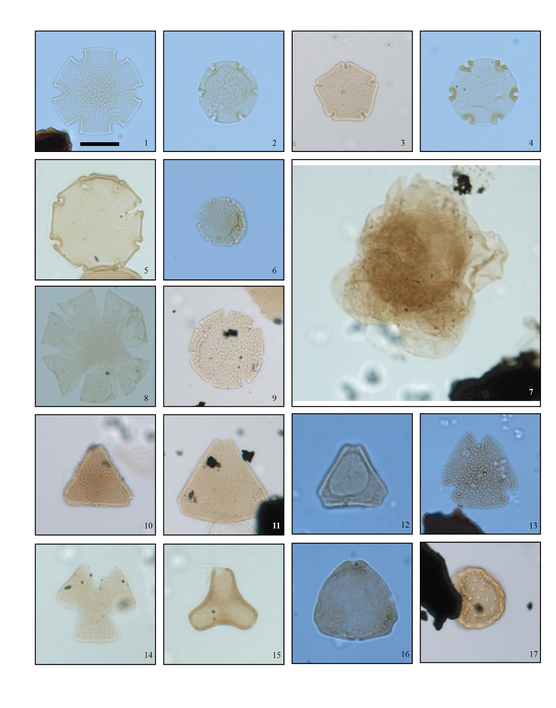

**Figure S5.1. Terrestrial Plate 1.** Light photomicrographs of select angiosperm pollen recovered on and off the Siple Coast, West Antarctica. Scale bar is ~15μm. Figure 1-2. *Nothofagidites lachlaniae* (1,2 – Site 3[UpB 92-1-93]), 3. *Nothofagidites cranwelliae* (Site 5 [WGZ-2015-GC-1 1-3cm]), 4-5. *Nothofagidites flemingii-saraensis-rocaensis* complex (4 – Site 3 [UpB 92-93-Core 1]; 5 – Site 6 [RISP 78-4b 2-4cm]), 6. *Nothofagidites matauraensis* (Site 6 [RISP 78-46 19-21cm]), 7. *Nothofagidites* sp. cluster (Site 6[RISP 78-6]), 8. *Nothofagidites asperus* (Site 4 [SLW-1-PC-1 25-27cm]), 9. *Nothofagidites suggatei* (Site 5 [WGZ-2015-GC-1 13-15cm]), 10. *Proteacidites pseudomoides* (Site 5 [WGZ-2015-GC-1 36-38cm]), 11. *Proteacidites tenuiexinus* (Site 5 [WGZ-2015-MC1A]), 12. *Propylipollis subscabratus* (Site 5 [WGZ-2015-MC5A]), 13. *Peninsulapollis askiniae* (Site 6 [RISP 78-4b 2-4cm]),14. *Peninsulapollis truswelliae* (Site 6 [RISP 78-4b 14-16cm]), 15. *Battenipollis sectilis* (Site 6[RISP 78-6]), 16. *Myricipites harrisii* (Site 5 [WGZ-2015-MC5A]), 17. *Chenopodipollis* sp. (Site 5 [WGZ-2015-GC-1 17-19cm]).

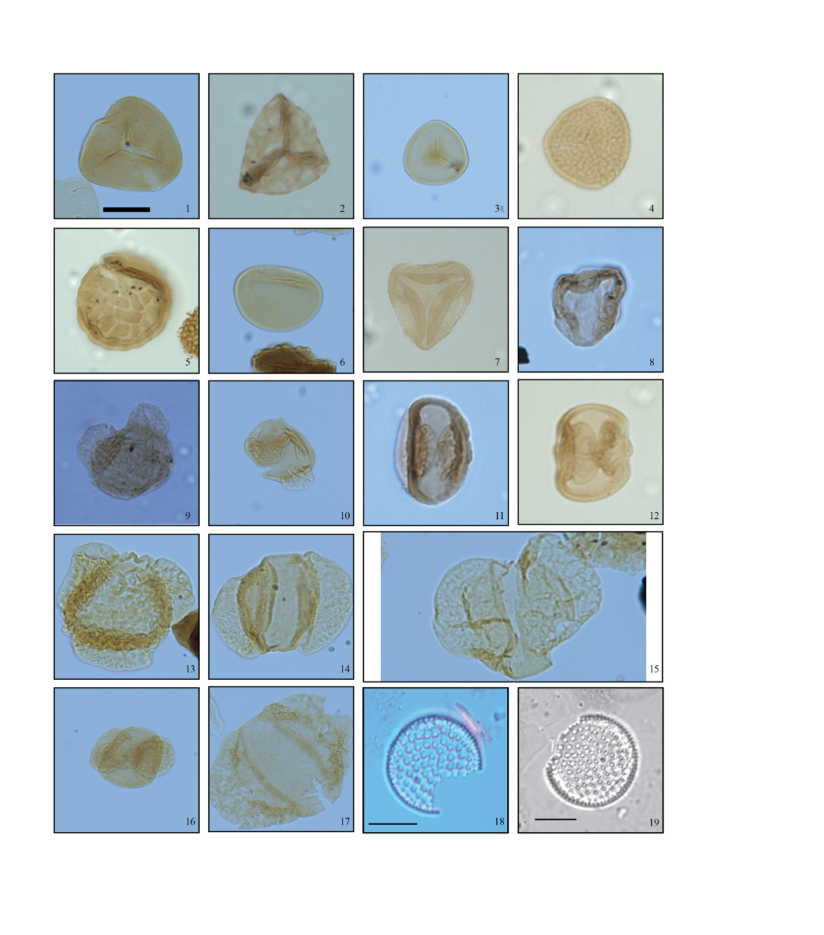

**Figure S5.2. Terrestrial Plate 2.** Light photomicrographs of select spore, gymnosperm pollen and freshwater diatoms recovered on and off the Siple Coast, West Antarctica. Scale bar is ~15μm. Figure 1. *Cyathidites minor* (Site 3 [UpB 92-93-Core 1]), 2. *Foveotriletes* sp. (Site 4 [SLW-1-PC-1 25-27cm]), 3. *Stereisporites antiquasporites* (Site 4 [SLW-1_MC1b 10-13cm]), 4. *Stereisporites regium* (Site 6 [RISP 78-46 19-21cm]), 5. *Coptospora* sp. (Site 6 [RISP 78-42 24.5-26.5cm]), 6. *Laevigatosporites ovatus* (Site 6 [SLW-PEC-1 30-40cm]), 7-8. *Trichotomosulcites subgranulatus* (7 – Site 4 [SLW-1-PC-1 47-49cm]; 8 – Site 5 [WGZ-2015-MC11A]), 9. *Microcachryidites antarcticus* (Site 5 [WGZ-2015-MC5A 0-2cm]), 10. *Podocarpidites* sp. (Site 4 [SLW-PEC-1 30-40cm]), 11. *Microalatidites paleogenicus* (Site 5 [WGZ-2015-MC5A]), 12. *Phyllocladidites mawsonii* (Site 6 [RISP 78-46 8-10cm]), 13. *Podocarpidites* sp. cf. *P. torquatus* (Site 3 [UpB 88-89 #1 2-22-90]), 14. *Podocarpidites* sp.(Site 3 [UpB 88-89 #1 2-22-90]), 15. *Podocarpidites ?marwickii* (Site 3 [UpB88-89 #1 2-22-90]), 16. *Podocarpidites* sp. cf. *P. otagoensis* (Site 2 [UpC 96-1-1-5A-Corewater]), 17. *Podocarpidites* sp. cf. *P. ellipticus* (Site 2 [UpC 96-1-1-5A-Corewater]), 18-19. *Stephanodiscus*? (*Mesodictyon*) (Site 4 [SLW-MC1B]).

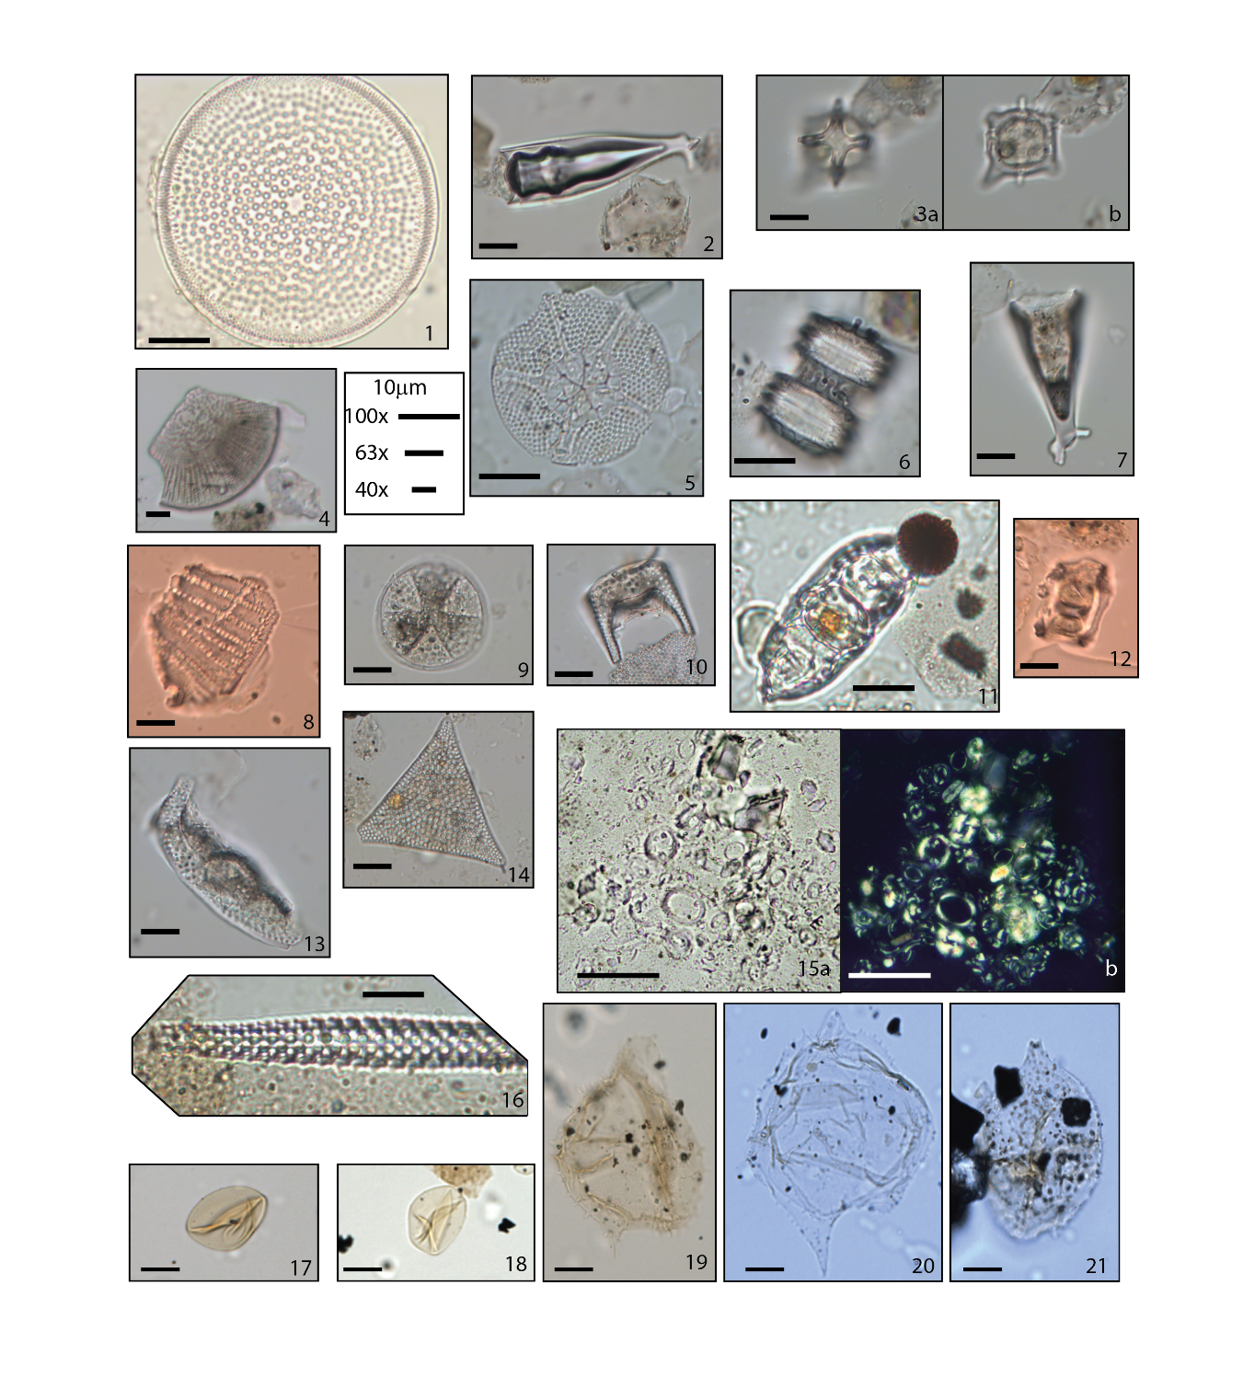

**Figure S5.3. Marine Plate 1.** Light photomicrographs of select marine diatoms, silicoflagellates, ebridians, calcareous nannoplankton, dinoflagellate cysts and acritarchs recovered on and off the Siple Coast, West Antarctica. Scale bar for dinoflagellate cysts and acritarchs is ~15μm; Marine diatom scale is shown for different objectives; calcareous nannoplankton scale represents 10m. Figure 1. *Actinocyclus octonarius* (Site 2 [KIS-96-10-1-CW-Coal]), 2, 7. *Pterotheca aculifera* (2- Site 5 [WGZ-GC-1-24cm]; 7-Site 5 [WGZ-GC-1-67-68cm]), 3a,b. *Dictyocha frenguelli* (silicoflagellate; Site 5 [WGZ-GC-1-67-68cm]); 4. *Aulacodiscus brownei* (4 – Site 5 [WGZ-GC-1-67-68cm]; 8 – Site 5 [WGZ-GC-1-63-64cm]), 5. *Asteromphalus symmetricus* (Site 5 [WGZ-GC-1-24cm]), 6. *Skeleonema ultriculosa* (Site 5 [WGZ-GC-4-47-49cm]), 9. *Actinoptychus senarius* (Site 5 [WGZ-GC-4-47-49cm]), 10. *Hemiaulus* spp. (Site 5 [WGZ-GC-4-47-49cm]), 11. *Hemiaulus polymorphus* (Site 2 [KIS-96-13-1-1]), 12. *Ammodocium ampulla* (Site 5 [WGZ-GC-1-63-64cm]), 13. *Hemiaulus polycistinorum* (Site 5 [WGZ-GC-4-47-49cm]), 14. *Pseudotriceratium radiosoreticulatum* (Site 5 [WGZ-GC-4-47-49cm]), 15a, b. *Reticulofenestra* assemblage from [*Scherer,* 1991 sediments] Site 3 [WIS-UpB] (b. in cross polar), 16. *Pyxilla reticulata* (Site 2 [KIS-00-4-1-2a]), 17, 18. *Leiosphaeridia* sp. (17 – Site 5 [WGZ-2015-GC1 44-46cm]; 18 – Site 5 [WGZ-2015-GC1 9-11cm]), 19, 20. *Spinidinium macmurdoense* (19 – Site 5 [WGZ-2015-MC1A]; 20 – Site 5 [WGZ-2015 MC11A]), 21. *Vozzhennikovia apertura* (21 – Site 5 [WGZ-2015-MC11A]).

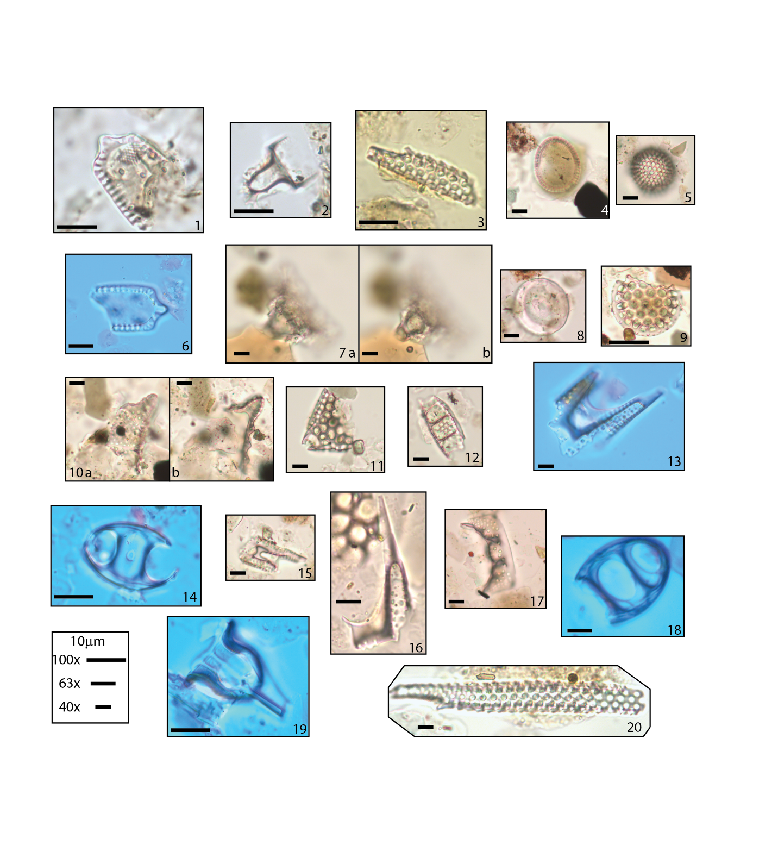

**Figure S5.4. Marine Plate 2.** Light photomicrographs of select marine diatoms recovered from Site 3 (BIS). Scale is shown for different objectives at 10m. Figure 1, 6. *Trinacria simulacrum* (1- Site 1 [BIS-98-2-2-3c (60-70cm)]; 6- Site 1 [BIS-98-2-2-3c (50-60cm)]), 2. *cf.* *Dicladia* spp. [*Harwood and Bohaty,* 2000] (Site 1 [BIS-98-2-2-3c (60-70cm)]), 3. *Pyxilla* fragment (Site 1 [BIS-98-2-2-3c (60-70cm)]), 4. *Paralia sulcata* “oval form” (Site 1 [BIS-98-2-2-3c (50-60cm)]), 5. *Stephanopyxis cf.* sp. F. [*Harwood and Bohaty,* 2000] (Site 1 [BIS-98-2-2-3c (50-60cm)]), 7a, b, 10a, b, *Triceratium crenulatum* (7a, b – Site 1 [BIS-98-2-2-3c (50-60cm)]; 10a, b – Site 1 [BIS-98-2-2-3a (20-30cm)]), 8. *Pseudopodrosira westii* (Site 1 [BIS-98-2-2-3a (20-30cm)]), 9. *Stephanopyxis grunowii* (Site 1 [BIS-98-2-2-3a (20-30cm)]), 11. *Triceratium favus* (Site 1 [BIS-98-2-2-3a (20-30cm)]), 12. *Hemiaulus polymorphus* (Site 1 [BIS-98-2-2-3a (20-30cm)]), 13, 15, 16 . *Hemiaulus subactus* (13, 15- Site 1 [BIS-98-2-2-3c (50-60cm)], 16- Site 1 [BIS-98-2-2-3a (20-30cm)]), 14, 18. *Anaulus* spp. (14 – Site 1 [BIS-98-2-2-3a (20-30cm)]; 18 – Site 1 [BIS-98-2-2-3c (50-60cm)]), 17. *Hemiaulus polymorphus* var. *morsiana* (Site 1 [BIS-98-2-2-3a (20-30cm)]), 19. *Pterotheca aculifera* (Site 1 [BIS-98-2-2-3c (50-60cm)]), 20. *Pyxilla reticulata* ( Site 1 [BIS-98-2-2-3a (20-30cm)]).

Text S6. Paxman19 and Wilson12 comparison

*Paxman et al.,* [2019] provide an assessment of the differences between their models and the established models of *Wilson et al.,* [2012]. In this section we plot all maximum, median, and minimum hypotheses (Fig. S6.1c-e) and suggest the best representative model based on our paleoenvironments. By taking into account the sea-level estimates (Fig 2b in the main text) throughout the Paleogene, our defined Mid-Paleogene Marine Event (MPME) and our Late-Paleogene Marine Event (LPME; Fig 2a in the main text) and our study locations (Fig. S6.1) we support the minimum paleotopographic reconstruction of *Wilson et al.,* [2012] as it fits best with tectonic studies, regional studies outlined in the main text, and our microfossil/biomarker data (Fig. S6b). The Paxman models tend to overestimate the landscape elevations near Site 5 (Fig. S6c,e), which has a very characteristic Late Eocene to Early Oligocene marine diatom assemblage. Additionally, studies of the East Antarctic, Cape Roberts Project core CRP-3, suggest the presence of a large ice sheet, which in some cases was marine terminating [*Galeotti et al.,* 2016]. While Paxman’s maximum and median model has a high likelihood of supporting large glaciers at the Eocene-Oligocene boundary, the paleoenvironments suggested by our study sites do not support these models. Even Paxman’s minimum reconstruction fails to represent the Eocene-Oligocene transition. The minimum still has land elevations too high in the region of Site 5 to support marine deposition during this time interval. Additionally, the large ice sheet suggested by the CRP-3 studies [*Galeotti et al.,* 2016] would likely not be supported, as the threshold to form ice during this transition to the cooler Oligocene still is about 1400 meters [*Wilson et al.,* 2013; *DeConto & Pollard,* 2003]. Models supported by the microfossil data from both studies are the “median” from *Paxman et al.,* [2019; Fig. S6e] and the “minimum” reconstruction from *Wilson et al.,* [2012; Fig. S6b].

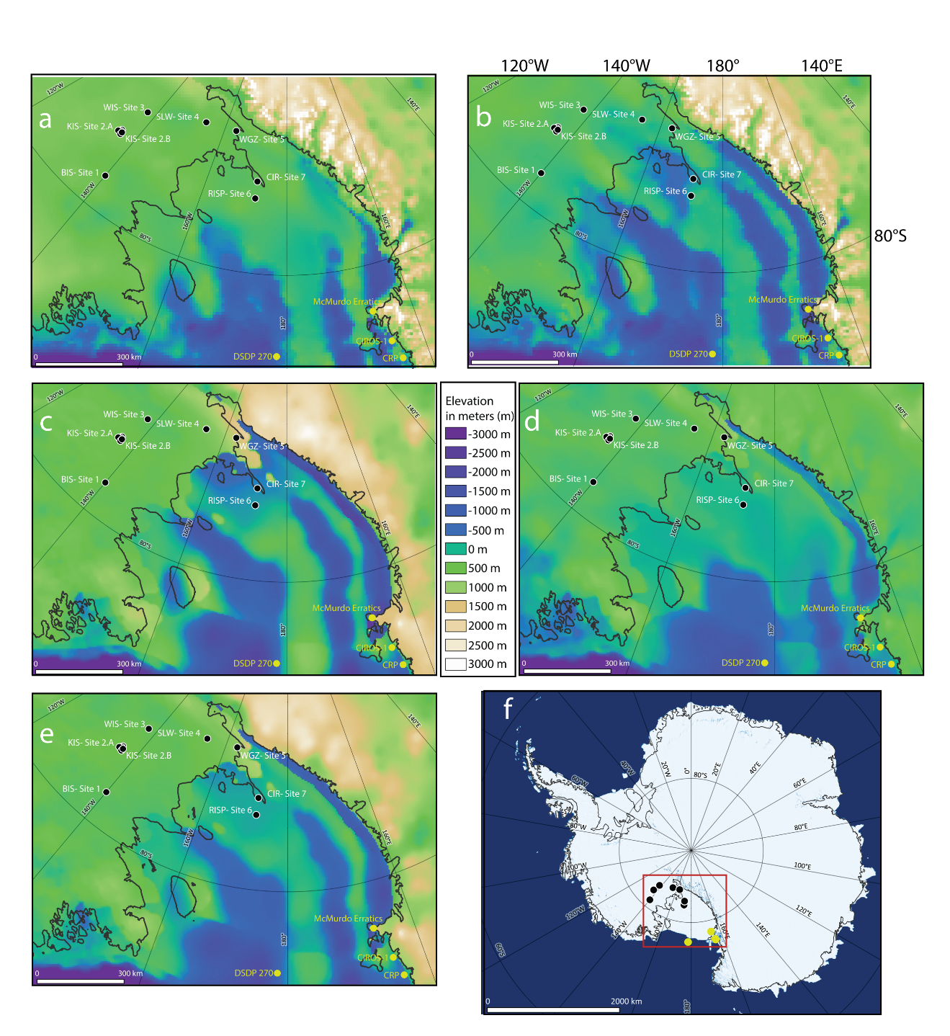

Figure S6.1. A comparison of Paleotopographic reconstructions: a) “maximum” and b) “minimum” reconstructions from *Wilson et al.,* [2012] with this studies sample locations. Color scale (between c & d) indicates meters above sea-level of bed topography for maps a-d. c) “maximum”, d) “minimum” e) “median” reconstructions from *Paxman et al.,* [2019] with our studied site locations on the most recent Eocene-Oligocene Paleotopography reconstructions. f) Antarctic map highlighting the locations of the sampled sites on the Antarctic continent [*Scambos et al.,* 2007] and modern grounding line [*Bindschadler et al.,* 2011]. For the purpose of this paper we use Ross Embayment to represent the region our sample locations cover (Fig. 1a-e) that are labeled 1-6: 1) Bindschadler Ice Stream, 2) Kamb Ice Stream, 3) Upstream Whillans Ice Stream (UpB in earlier literature), 4) Subglacial Lake Whillans, downstream Whillans Ice Stream, 5) Whillans Ice Stream grounding zone, 6) Ross Ice Shelf Project (Site J-9 in earlier literature), 7) Crary Ice Rise (Figure made using QGIS [*QGIS Development Team,* 2019]). Additionally, the Cape Roberts Project (CRP) and Cenozoic Investigation of the Western Ross Sea core (CIROS-1) both part of the Victoria Land Basin, DSDP site 270, and the McMurdo Erratics locations have been added in yellow for discussion.

Text S7. Palynomorphs

Terrestrial organic microfossils (pollen and spores) are abundant in the sediments, with concentrations ranging from 29,741 to 207,593 specimens per gram of dried sediments. Samples from UpB and upstream KIS have the highest pollen concentrations.

Total palynomorph species recovered are also quite diverse, with mostly podocarps and diverse beech species, with at least 12 morphotypes, including the warm-loving *Nothofagidites* *brassii* type that apparently disappears from Antarctic assemblages at the end of the Eocene in most locations. All specimens display a similar thermal maturity and preservation. Additionally, samples include only very rare Paleocene genera such as, *Battenipollis* spp. and *Gambierina* spp., which aids in our interpretation of terrestrial ages. Based on all these observations, a dominating late Eocene provenance is most likely.